Midterm Exam

CSC 120 Computing Fundamentals I

Due Date: 06/23/2021 11:59 pm

# Instructions

* This is an open book exam. This means you can refer to the textbook or online material for this exam. **However**, you need to cite the sources you use for every answer to get full credit. Please paste the URL for online sources or name of book, chapter number for print material.
* **DO NOT** copy paste text directly from the websites/other sources. Points will be deducted.
* This exam will be **100 points** and will constitute **15% of the overall grade** for this course.
* The aim of this assignment is to help you become self-learners so what matters is your own interpretation. You can use sources to make your argument. This exam will test your understanding of computing basics and how you apply the basics to new scenarios. We are moving away from memorization in order to develop self-discovery and research skills necessary in real-world scenarios.
* Make a separate Word document with the answers. Make sure that you write the section name and question number CLEARLY. Upload the file with your firstname_lastname on Blackboard.
* Attempt all questions! Good luck!

# Number Systems and Digital Logic

|  |  |
| --- | --- |
| 1. Convert the following to bytes  # Chapter 1.2 of textbook  # 8 bits in one byte   1. 1024 bits = 128 bytes 2. 2048 bits = 256 bytes 3. 4096 bits = 512 bytes 4. 8192 bits = 1024 bytes   (e) 16384 bits = 2048 bytes | 5 points |
| 2. What is the MSB **and** LSB of the following:  # Chapter 1.2 of textbook  # Most significant bit is leftmost bit, least significant bit is rightmost bit | 2 points |

1. 100000

MSB = 1 LSB = 0

1. 11101010

MSB = 1 LSB = 0

1. With the help of the NAND truth table, answer the following questions. You will be performing a bit-by-bit operation.

# Chapter 1.1 of textbook

4 points

* 1. 11101 NAND 10101 = 01010
  2. 10111 NAND 00101 = 11010

1. With the help of the XOR truth table, answer the following questions. You will be performing a bit-by-bit operation.

# Chapter 1.1 of textbook

# XOR produces an output of 1 when one of the inputs is true and the other is false

4 points

* 1. 11101 XOR 10101 = 01000
  2. 10111 XOR 00101 = 10010

1. You have an 8 bit binary number 11110000. What happens when you AND this number with any other 8 bit number. Try out a few examples and try to generalize your observations.

|  |  |
| --- | --- |
| Hint: Research about an AND bit mask and how it is used.  #Chapter 1.1  Starting from the leftmost bits, if both bits are 1, the output will be 1, otherwise the output will be 0. Then you move to the next bit and repeat the same process until you get to the last bit. | 3 points |
| 6. Convert the following hexadecimal to binary  # https://owlcation.com/stem/How-to-Convert-Hex-to-Binary-and-Binary-to-Hexadecimal   * 0x3A21 0011101000100001 * 0x11F0 0001000111110000 | 4 points |
| 7. Convert the following hexadecimal to decimal  # https://www.binaryhexconverter.com/hex-to-decimal-converter   * 0xFA 250 * 0x10 16 | 4 points |
| 8. Convert the following decimal to hexadecimal | 4 points |

* + 103 = 67
  + 210

# Programming Questions

You can use any Python environment (Colab, Pycharm or command line) to write your programs. For each question, provide a separate screenshot of the code alongwith a url to the original code or Python file.

1. Write a python program to find MSB (Most Significant Bit) for an input string for any given value. Your program should accept your strings inputs and provide a "0" or "1" as an output. Use the sample inputs to test your program.

Sample inputs: "10101", "1000", "010000", "010100" 5 points

# <https://thispointer.com/python-how-to-get-first-n-characters-in-a-string/>

<https://colab.research.google.com/drive/1AXxJco0Q3T0lRl51iZCXDbBZ3Ncrkwp0?usp=sharing>

1. Write a Python program that determines if a username is valid or invalid. The input to your program is a string which is the username. Below are the requirements for a valid username.
   * + The length of the username should be greater than 6 characters.
     + The username must contain lowercase characters only. No uppercase characters are permitted
     + The username may contain numbers or special characters alongwith lowercase characters.

**Input #1** : "abc1234" **Output #1** : "Valid username"

**Input #2**: "abc123"

**Output #2** : "Invalid username. The length should be greater than 6 characters"

**Input #3** : "Abc1234"

**Output #3** : "Invalid username. Uppercase character found"

**Input #4** : "ABCxyzw"

**Output #4** : "Invalid username. Uppercase character found" 5 points

**Hint**: Use "if" condition in your program. Use the islower() method to verify is the string is lowercase. Read online on how to use islower() method in your code.

<https://colab.research.google.com/drive/1iH0jVw29U67XKpOVdPbNZfqQGTEEkCLZ?usp=sharing>

1. Correct the indentation for the code in Figure: 1. Report the errors you receive when you copy-paste this code and run it. What are the changes you make to the code to print the numbers 8 and 9? 5 points

**Hint**: Apply indentation to the code.

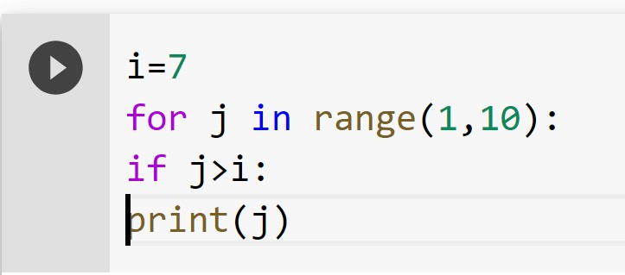

Figure 1: Correct the indentation of Python code snippet

ERROR message: IndentationError: expected an indented block

Code with correct indentation that prints the numbers 8 and 9:

https://colab.research.google.com/drive/1xyT6EMTWl4IGs7odI0zRkdMR7nHWFZLU?usp=sharing

1. Print a list of powers of 2 from 0 to 20 using for loops in Python. Your program should print the following output 5 points

**Sample Output #** : 2 4 8 16 32 64 128 256 512 1024

**Hint**: You should use a for loop and can print the output on a new line.

https://www.digitalocean.com/community/tutorials/how-to-do-math-in-python-3-with-operatorsv

1. In Python, consider the code sample in Figure: 2 5 points

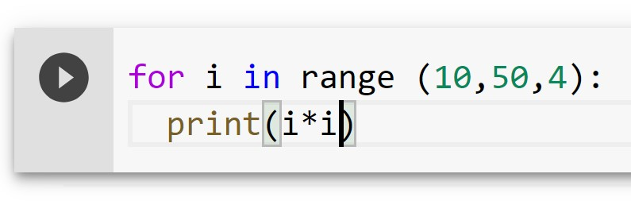

Figure 2: Python code snippet 1

https://www.w3schools.com/python/gloss_python_for_range.asp

* 1. What does 10 represent? The for loop will start with i = 10
  2. What does 50 represent? The for loop will continue until i =50
  3. What does 4 represent? With each iteration, i will increment by 4
  4. (d) What gets printed?

100, 196, 324,484, 676, 900, 1156, 1444, 1764, 2116

1. In Python consider the code in Figure: 3 what value would be printed by the following operation. Why? 5 points

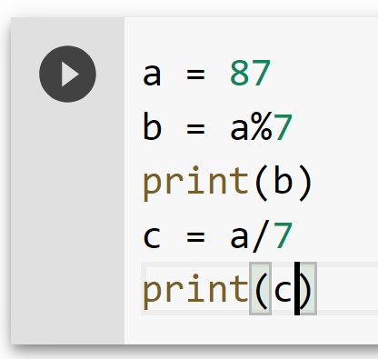

Figure 3: Python code snippet 2

a = 87 b = a%7 = 3 c = a/7 = 12.428571428571429

print(b) will have an output of 3 because 87 divided by 7 has a remainder of 3.

print(c) will have an output of 12.428571428571429 because 87 divided by 7 = 12.428571428571429.

# Computer Organization

For these questions please refer to the Appendix C at the back of your textbook and Chapter 2.

|  |  |
| --- | --- |
| 1. How many CPU registers are provided for this architecture? 16 | 3 points |
| 2. How many unique memory addresses are provided for this architecture? 256 | 2 points |
| 3. What is the size in bytes of each instruction for this architecture? 2 | 5 points |
| 4. How many bits make up the opcode and the operand for each instruction? 4 bits make up the opcode and 12 bits make up the operand | 5 points |

5. What operation would the following instruction perform? 0x15B3. Assume that memory cell B3 has the value 12. (Please provide a description identical to Appendix C examples

|  |  |
| --- | --- |
| in the textbook) 0x15B3 would cause the contents of the memory cell located at address 0xB3 (12) to be placed in register 0x5. | 5 points |
| 6. What operation would the following instruction perform? 0x25C3.  0x25C3 would cause the value 0xC3 to be placed in register 5. | 5 points |
| 7. What operation would the following instruction perform? 0x71B2.  0x71B2 would cause the result of ORing the contents of registers 0xB and 0x2 to be placed in register 0x1. | 5 points |

# General Awareness (10 points)

Read the article and answer the questions. What ergonomic guidelines are you currently following? What guidelines are you not following. List all changes that you plan to make over the next few weeks to improve your posture.

<https://uhs.princeton.edu/health-resources/ergonomics-computer-use>

**CURRENTLY FOLLOWING**

Am currently following ergonomic guidelines suggested for mouse usage, monitor position, and chair position.

**THINGS TO IMPROVE**

resting wrists while typing, having back end of keyboard tilted up instead of tilted down, keyboard too high, elbows should be bent at 90 degrees, wiping off monitor to reduce eye irritation caused by dust

# EXTRA CREDIT : Feedback Questions 10 points

1. On a scale of 1 to 10, how would you rate your programming ability at the start of the course. 6

On a scale of 1 to 10, how would you rate your programming ability right now, the middle of the course. Do you see an improvement? 7. I have seen some improvement.

1. How would you rate the difficulty of the labs? Would you like the labs to become simpler or more challenging. I would rate the difficulty a 6 out of 10. The labs could be slightly more challenging but overall I think it is a reasonable difficulty.
2. What specific topics are you looking forward to in the next four weeks?

I am looking forward to all of the topics. This is my first experience working with python, so I am looking forward to practicing more coding problems. Operating system concepts and introduction to networking also sound very interesting.